4.5 LIQUID CRYSTAL DISPLAY

A liquid crystal display (LCD) is a thin, flat display device made up of any number of color or monochrome pixels arrayed in front of a light source or reflector. Each pixel consists of a column of liquid crystal molecules suspended between two transparent electrodes, and two polarizing filters, the axes of polarity of which are perpendicular to each other. Without the liquid crystals between them, light passing through one would be blocked by the other. The liquid crystal twists the polarization of light entering one filter to allow it to pass through the other.
Many microcontroller devices use 'smart LCD' displays to output visual information. LCD displays designed around Hitachi's LCD HD44780 module, are inexpensive, easy to use, and it is even possible to produce a readout using the 8x80 pixels of the display. They have a standard ASCII set of characters and mathematical symbols.
For an 8-bit data bus, the display requires a +5V supply plus 11 I/O lines. For a 4-bit data bus it only requires the supply lines plus seven extra lines. When the LCD display is not enabled, data lines are tri-state and they do not interfere with the operation of the microcontroller.
Data can be placed at any location on the LCD. For 16×2 LCD, the address locations

are:

First line 80 81 82 83 84 85 86 through 8F

Second line C0 C1 C2 C3 C4 C5 C6 through CF

Fig 4.22 Address locations for a 2x16 line LCD

4.5.1 SIGNALS TO THE LCD

The LCD also requires 3 control lines from the microcontroller:

1) Enable (E)

This line allows access to the display through R/W and RS lines. When this line is low, the LCD is disabled and ignores signals from R/W and RS. When (E) line is high, the LCD checks the state of the two control lines and responds accordingly.
2) Read/Write (R/W)

This line determines the direction of data between the LCD and microcontroller.

When it is low, data is written to the LCD. When it is high, data is read from the

LCD.

3) Register select (RS)

With the help of this line, the LCD interprets the type of data on data lines. When it is low, an instruction is being written to the LCD. When it is high, a character is being written to the LCD.
4.5.1.1 Logic status on control lines:

• E - 0 Access to LCD disabled

- 1 Access to LCD enabled

• R/W - 0 Writing data to LCD

- 1 Reading data from LCD

• RS - 0 Instruction

- 1 Character

4.5.1.2 Writing and reading the data from the LCD:

Writing data to the LCD is done in several steps:

1) Set R/W bit to low

2) Set RS bit to logic 0 or 1 (instruction or character)

3) Set data to data lines (if it is writing)

4) Set E line to high

5) Set E line to low

Read data from data lines (if it is reading):

1) Set R/W bit to high

2) Set RS bit to logic 0 or 1 (instruction or character)

3) Set data to data lines (if it is writing)

4) Set E line to high

5) Set E line to low

4.5.2 PIN DESCRIPTION

Most LCDs with 1 controller has 14 Pins and LCDs with 2 controller has 16 Pins

(two pins are extra in both for back-light LED connections).

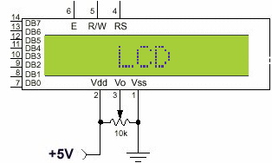

Fig 4.23 Pin diagram of 2x16 line LCD

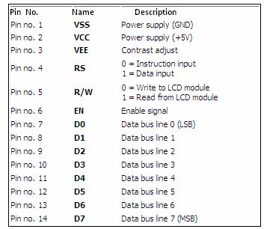

Table 4.23 Pin description of the LCD

